

**T.C.**

**MARMARA UNIVERSITY**

**FACULTY of ENGINEERING**

**COMPUTER ENGINEERING DEPARTMENT**

**CSE 4074 – Computer Networks**

**Socket Programming – HTTP-based Room Reservation**

Furkan Çetin – 150119627

Kutay Başkurt – 150119645

Hasan Mert Yalçın – 150119647

Supervised by

Ömer Korçak

**Socket Programming**

Socket programming is a way of establishing a communication channel between a client and a server on a computer network. Python provides libraries to work with sockets, which makes it relatively easy to write network programs in the Python language.

A socket is an endpoint of a communication channel that two programs use to communicate with each other. A client program creates a socket on its end of the communication and attempts to connect that socket to a server. The server creates a socket on its end of the communication and listens for incoming connection requests. When a client connects to the server, the server creates a new socket for the client and establishes a connection with the client's socket.

Once a connection has been established, the client and server can send data back and forth over the socket. Socket programming allows for low-level communication between programs, and it is a powerful tool for building networked applications.

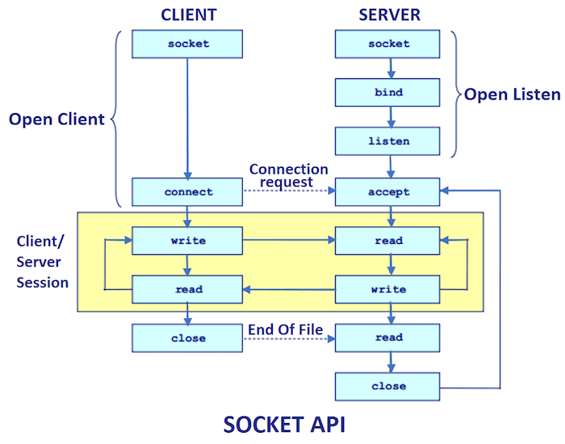

**Sample outputs of the project are given below with their explanations:**

**metin içeren bir resim

Açıklama otomatik olarak oluşturuldu**

The project starts with an empty room database. A new room is added with the room name.

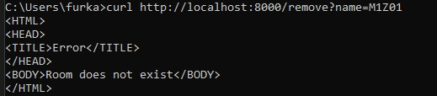

If the room to be removed is not found in the database, it sends an HTTP 403 message.

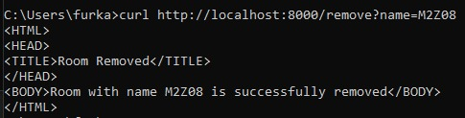

If the room to be removed is in the database, it is removed and an HTTP 200 OK message is sent.

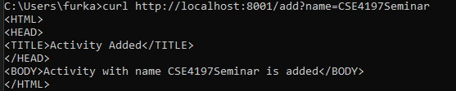

The project starts with an empty activity database. A new activity is added with the activity name.

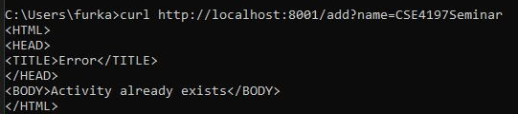

If an added activity is wanted to be added again, it returns an HTTP 403 Forbidden message since this activity is also present in the database and says that this activity already exists in the database.

metin içeren bir resim

Açıklama otomatik olarak oluşturuldu

When this request is received, the server first contacts the Activity Server and checks whether this activity exists. If there is this activity, it communicates with the Room Server and if all input parameters are valid, it makes a reservation and sends an HTTP 200 OK message.

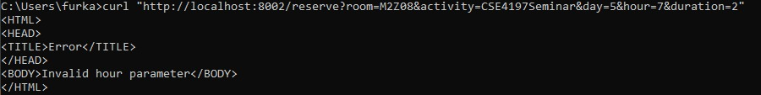

When this request is received, the server first contacts the Activity Server and checks whether this activity exists. If there is this activity, it communicates with the Room Server and if input parameters are not valid, it sends back an HTTP 400 Bad Request message.

**Diagram of Activity Server**

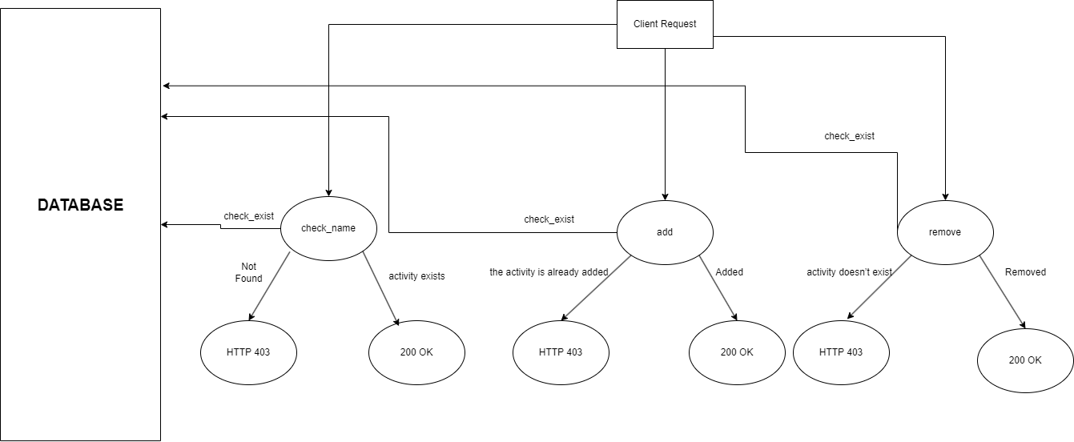

**Diagram of Room Server**

